User Guide

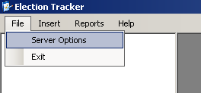

**File Menu:**

*Server Options*

The Server Options item is where the database connection info is accessed and modified. To access the Server Options menu click File -> Server Options. The dialog box “MySQL Server Settings” will pop up.

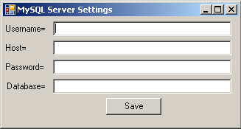If there has been a connection already made to an existing database, the information will be displayed.

*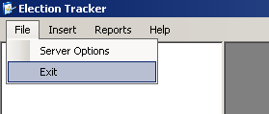Exit*

The Exit item exits the program. This is one of two ways to exit the program safely. To exit using this method, Click File -> Exit.

**Creating a new election using the Insert Menu**

The Insert menu item is where new candidates, contests, counties, elections, political parties, and voting results are inserted into the records. This section will step through how to access and use each function to set up a new election date. Not all steps will be required to set up a new election if there is previous data from past elections stored in the program.

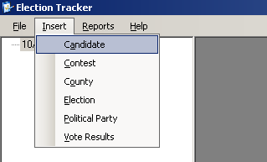An election consists of four main elements: the election date, the contents to be held on that election date, the candidates involved in those contests, and the counties where the contest will be held. Before an election can be created, there must be contests, candidates, and counties in the program. If these items have already been created, skip to step 4 to continue.

*Step One: Adding an active candidate*

To add a new candidate, select the Candidate item from the Insert drop down menu. The candidate window will appear.

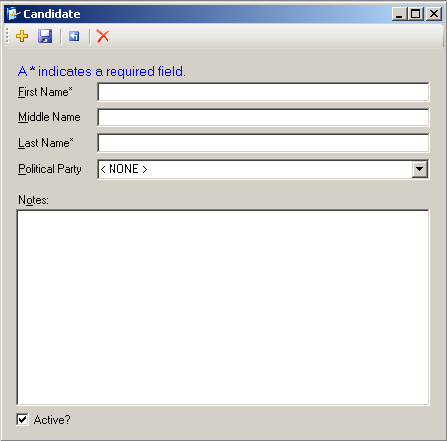Inside the candidate window, the first name, middle name, last name, political party, and any notes about the candidate can be added by filling in the text boxes next to the appropriate labels.

To save a candidate, click the floppy disk icon FloppyButton.PNG on the file menu within the window. The information of the candidate will still be visible.

To start a new candidate, click the yellow plus button PlusButton.PNG on the file menu. A popup box will ask to save the existing candidate data.

To reset all of the fields of a candidate click the reset button ResetButton.PNGon the file menu.

To delete the current candidate, click the red X RedX.PNG on the file menu.

The Active? checkbox on the bottom of the screen indicates whether this candidate is active or not. If unchecked, the candidate will not be able to be placed in any contest.

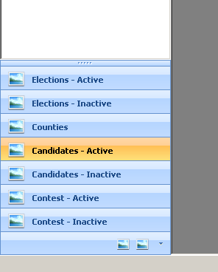

To view all active candidates, click the Candidates- Active button on the left side bar. This will show all active candidates in the white space above the buttons. Double click one of the names to show the candidates info in the Candidate window. The candidate’s information can be modified in any way or the record deleted from here.

Click the Candidates – Inactive button to view and modify the data for all of the inactive candidates.

*Step 2: Adding a county*

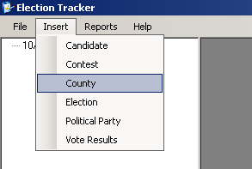The next step to creating a new election using the Insert Menu is to add a county or counties where a contest will be held.

To add a new county, select the County within the Insert drop down menu from. The County window will appear.

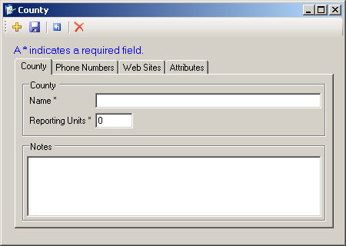The County Window allows new counties to be created or current counties to be modified.

Enter the desired name for the county in the Name textfield and the number of Reporting Units for the county. If desired, use the tabs labeled “County”, “Phone Numbers”, “Web Sites”, and “Attributes” to add extra information. Note that the only information required for a new county is the name of the county and the number of reporting units. Both are located in the “County” tab.

To start a new county click the yellow plus PlusButton.PNG button.

To save the current county click the save button FloppyButton.PNG that looks like a floppy disk.

To reset the current county click the reset ResetButton.PNG button.

To delete the current county click the delete button RedX.PNG.

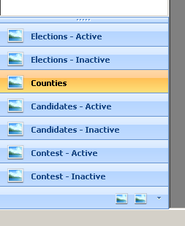

To access previously entered counties use the left side panel button labeled Counties. The list of all entered counties will appear in the white space above the buttons on the left side panel. To view and/or modify any existing county, double click on the county name and it’s information will appear in the County Window.

*Step 3: Adding a contest*

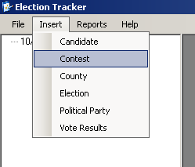Now that there are candidates and counties, contests can be created using the Insert Menu.

To access the Contest Window to create new contests, select the Contest item from the Insert drop down menu.

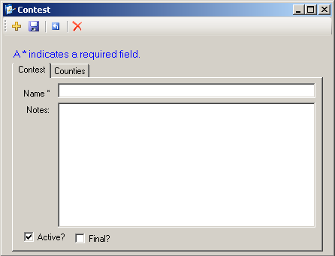A new contest requires a name, the counties involved in the contest, and the number of reporting units within the county that are involved in the contest.

Type in the contest name in the textfield named Name within the Contest tab.

Once the name has been inputted, make sure the checkbox labeled Active? is checked to make the contest active. If the contest is to be inactive, make sure the checkbox is clear.

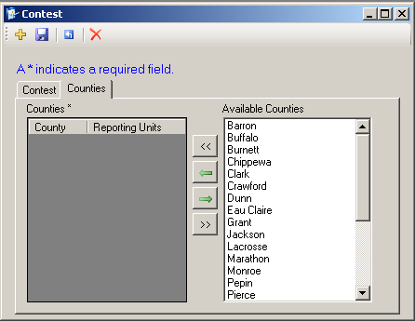Click on the Counties tab to bring up the county insertion menu. On the left side the current counties involved with the contest will be listed along with their reported units. On the right is the list of the available counties that can be added to the current contest. Click the  
*add all* button AddAllCounties.PNG to add all available counties to the current contest. To add individual counties, highlight the name of the county in the available counties menu by clicking on the name of the county and pressing the *add county* button AddCountyButton.PNG. To add a group of counties, click the desired county, hold the mouse button, and move the cursor to the desired county. This will highlight multiple counties. If the counties are not in order, hold the *Ctrl* button the keyboard and click each desired county. This will highlight each county. Then press the *add county* button AddCountyButton.PNG to add all selected counties. This makes adding multiple counties go much faster.

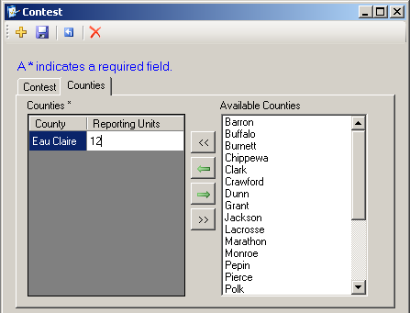A county can be removed by selecting it from the left Counties menu and pressing the *remove county* button RemoveCounty.PNG. To removed all of the entered counties press the *remove all* button RemoveAllcounties.PNG. A dialog box will pop-up to confirm the removal of all counties.

To add the number of reporting units of the county for the current contest, double click the number next to the name of the county in the right side Counties menu, then type in the number of reporting units for the county and press enter on the keyboard. To change a number of reporting units for a county, double click the number and use the keyboard to modify the amount.

Once all of the counties and their reporting units have been entered, click the save button FloppyButton.PNG to save the current contest.

To start a new contest click the yellow plus button PlusButton.PNG.

To reset the current contest click the reset button ResetButton.PNG.

To delete the current contest click the delete buttonRedX.PNG .

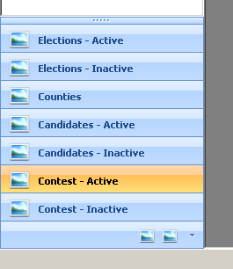To view the entered active contest, click the *Contest-Active* button the left side panel. The names of all the active contests will appear in the white space above the buttons.

To view and/or modify the entered active contests, double click the name of the contest. The contest window will pop up with the details of the selected contest.

To view the entered inactive contests, click the *Contest – Inactive* button on the left side panel. The names of the entered contests that are inactive will appear in the white space above.

To view and/or modify the entered inactive contests, double click the name of the contest. The contest window will pop up with the details of the selected contest.

*Step 4: Creating an election*

Now that there are active contests, elections can be created using the contests.

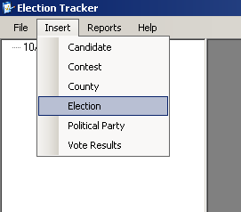To create a new election, select the Election item from the Insert drop down menu. The Election window will appear.

An election consists of candidates, counties, and contests. If there are no contests, candidates, or counties, please refer to steps 1-3 for info of how to add candidates, counties, and contests.

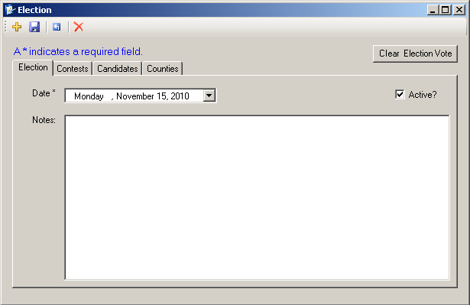A new election first requires a date. The Election window has 4 main tabs: Election, Contests, Candidates, and Counties. The first tab which will automatically open is the Election tab. Here is where the date of the election is set.

To set the date, click the arrow button next to the date text field. Make sure the Active? checkbox is checked to make the election active.

Once the date for the election has been set, the contests must be added. Click the Contests tab within the Election window.

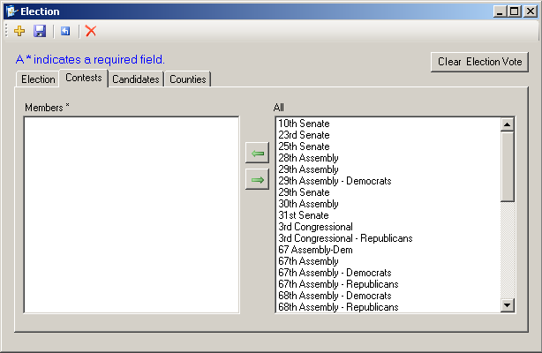Within the contest tab is where the contests can be added to the election. On the left of the contests tab there will be the current contests associated with the election. If creating a new election, this area will be blank. On the right of the contests that there will be all of the available, active contests.

To add a contest to the election, select the contest from the right menu and click the AddCountyButton.PNG button to add it to the current election.

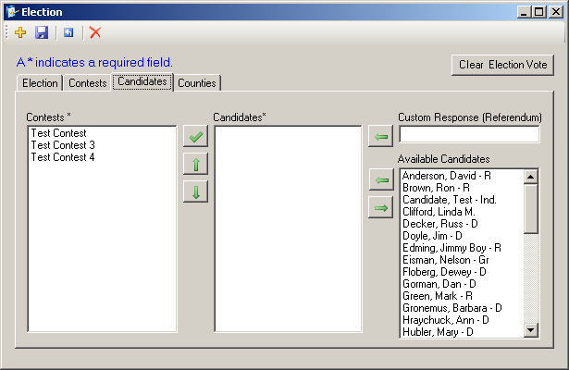Once all counties have been added, click the Candidates tab to begin associating candidates with the correct contests.

Within the Candidates tab there are three menus. On the left there are all of the contests that have been added to the election. In the middle are the candidates associated with the contests (this should be blank if creating an election for the first time). On the right are all of the active candidates.

To add a candidate to a contest, first select the contest from the Contests menu on the right and select the name of the candidate from the Available Candidates menu on the left. Once the candidate is selected, click the AddCountyButton.PNG button to add the candidate to the contests. Repeat this process until all contests have candidates associated with them.

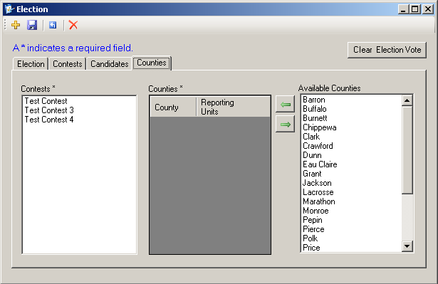Once all of the contests are populated with candidates, click the Counties tab to associate counties with the newly added contests.

The Counties tab consists of 3 menus. On the left is the Contests list that contains all of the added contests to the current election. In the middle is Counties list which is a list of all the counties associated with the selected contests (should be blank if creating a new contest for the first time). On the right is the Available Counties list which contains all of the counties that have been added. If this list is blank, refer to step 3 to add a county.

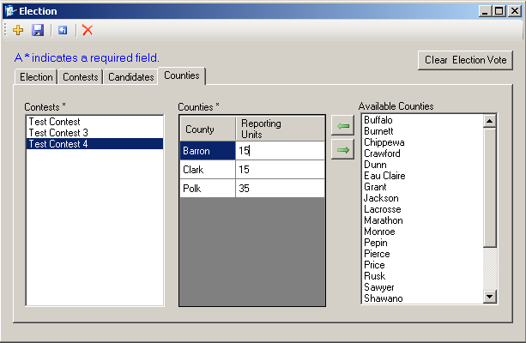

To associate counties with contest, select a contest in the left Contests list then select the county associated with the contest in the right Available Counties list. Once the correct county has been selected, click the AddCountyButton.PNG button to add it to the selected contest. The county will now appear in the Counties menu with the number of reporting units besides it. Remember that certain contests will not use all of the reporting units in a county. To change the number of reporting units of a county, double click the reporting units of a county for the contest and then use the keyboard to update the number of reporting units in the counties. Repeat these steps for every contest.

At any time during creating a new or editing an old contest, click the FloppyButton.PNGbutton to save the progress.

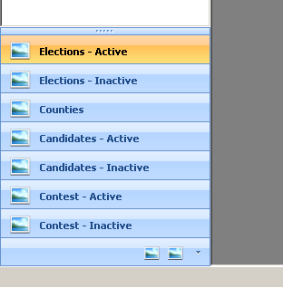

To reset the election completely, click the ResetButton.PNG button.

Do delete the current election press the RedX.PNG button.

To view or edit an existing Election, click the Elections – Active button in the side panel. All active elections will appear in the white panel above the buttons. To view or edit any existing inactive elections, click the Elections – Inactive button.

**Updating Voting Results to the Active Election**

On the day of an election, the Election Tracker software is used to track the status of each different contest throughout the state. First an election must be created and populated with the correct information. If there are no previously populated elections for the current election day, one must be created. The section **Creating a new election using the Insert Menu** will walk through how to create a new election. If an election is already created, continue on with this guide.

During an election the votes must be entered manually into the software so that the Election Tracker software can print out reports of the voting progress in each county for each contest. This process is made very easy with one window called the Enter Votes window.

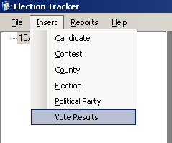To access the Enter Votes window, select the Vote Results menu item from the Insert drop down menu. This will open the Enter Votes window.

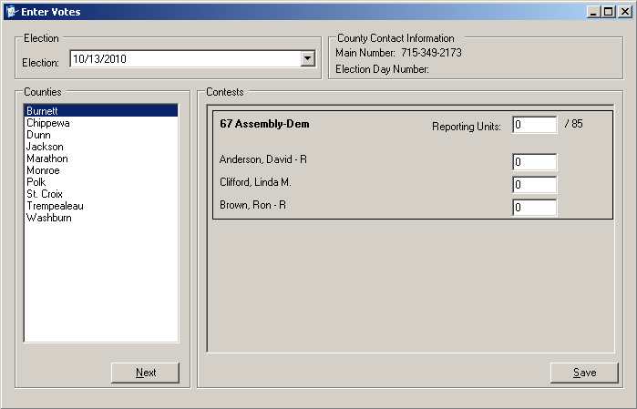

The Enter Votes window is where all vote entry is done during an election. The Enter Votes window consists of two main parts: the Counties list located on the left, and the Contests menu located on the right.

To start make sure that the correct election is selected on the top left side of the window. Use the arrow in the Election text field to select the correct election if the incorrect election is currently active.

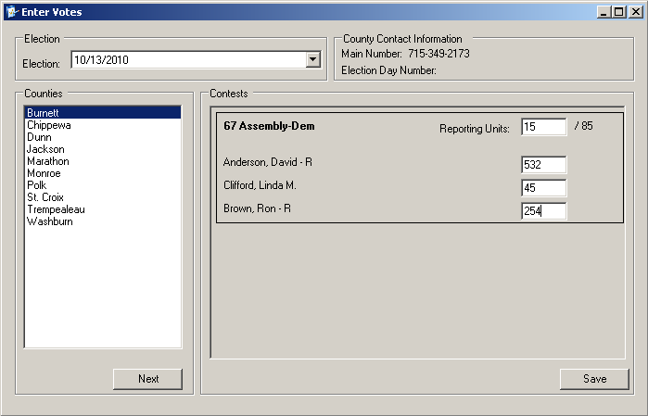Once the correct election has been selected votes can now be entered.

To enter an updated tally of votes to a certain county, select the name of the count in the left Counties menu. The contests, the number of reporting units per contest and the vote numbers each candidate will appear in the right Contests menu. To update any of these, simply change the value of the textbox adjacent to the reporting units or candidates and click save.